Professional High School

**FIRST QUARTER**

**ICT 9 Project – HyperText Markup Language (20points)**

NAME: _Zaina Clarisse T. Eusebio_________________________________________________ SCORE: _______________

GRADE AND SECTION: _9-Ruby_____________ DATE: _10/11/22______

**DIRECTIONS:**

1. Create a ticket selling website.
2. Insert the following HTML Elements:

* Text
* Images
* Tables
* Background color
* Hyperlinks

1. Save your files following the format:

* **CAMPUS_ICT9Section_Q1Project_LastName_FirstName** (docx or pdf)
* **CAMPUS_ICT9Section_Q1Project_LastName_FirstName.html**

1. Create a folder and rename it to **Q1Project_LastName.** Move your files (html, images, and docx/pdf) into the folder.
2. Compress **Q1Project_LastName** folder. Submit the compressed file through the OB Platform.

SAMPLE OUTPUT:

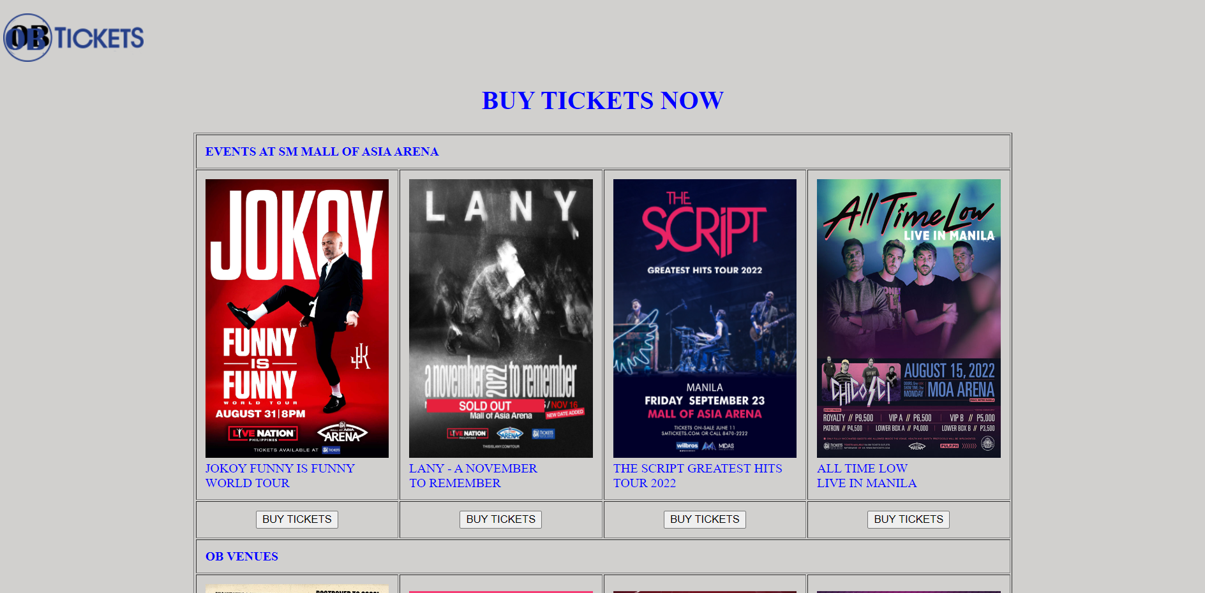

CRITERIA:

|  |  |  |  |  |  |
| --- | --- | --- | --- | --- | --- |
|  | **E =5** | **AS = 4** | **S = 3** | **NI = 2** | **P = 1** |
| **Execution of Instructions** | Executed the instructions efficiently. Followed the procedures accurately. | Followed most of the instructions. One instruction is skipped; however, it does not affect the over-all output. | The activity shows the basic HTML structure.  There are two to three errors in the activity. | The activity is missing important contents due to omission of four to five instructions. | The activity is full of technical errors due to misinterpretation of all instructions. |
| **Syntax and Content** | All the contents are organized and presented in a uniform format with distinctions between major contents and supporting details. | Most contents are organized and well presented. Formatting where necessary is applied. However, one formatting requirement is missing. | The major contents are formatted; however, two to three formatting requirements are missing. | The activity contains formatting; however, four to five formatting requirements are missing. | The activity was laid out poorly. Contents are not placed in proper order. All formatting requirements are missing. |
| **Accomplished task within the time limit.** | The activity was completed before the allotted time elapsed. | The activity was completed within the given time. | The activity was not completed within the given time. A five-minute extension was given in order to complete the activity. | The activity was not completed within the given time. A ten-minute extension was given in order to complete the activity. | The activity was not completed within the given time. A fifteen-minute extension was given in order to complete the activity. |
| **General Output**  **- Format / Layout**  **- Creativity /  Originality** | Pre-planning and proper execution is very evident. All requirements for the activities are evident in the final output. | The activity contains one minimal inaccuracy observed; however, it did not affect the overall output.  Applies original design in most aspect of the activity. | Two to three major components of the activity are missing.  The activity is presented with some unique design details. | The activity is very simple and lacks effort in most areas. Four to five components of the activity are missing.  Lacks originality. Design is a duplicate of the sample. | The activity has no impact at all. All major components of the activity are missing.  Failed to create even the simplest design for the activity. |
| **TOTAL** | **20** | **16** | **12** | **8** | **4** |

**CODES (insert screen captures of your codes)**

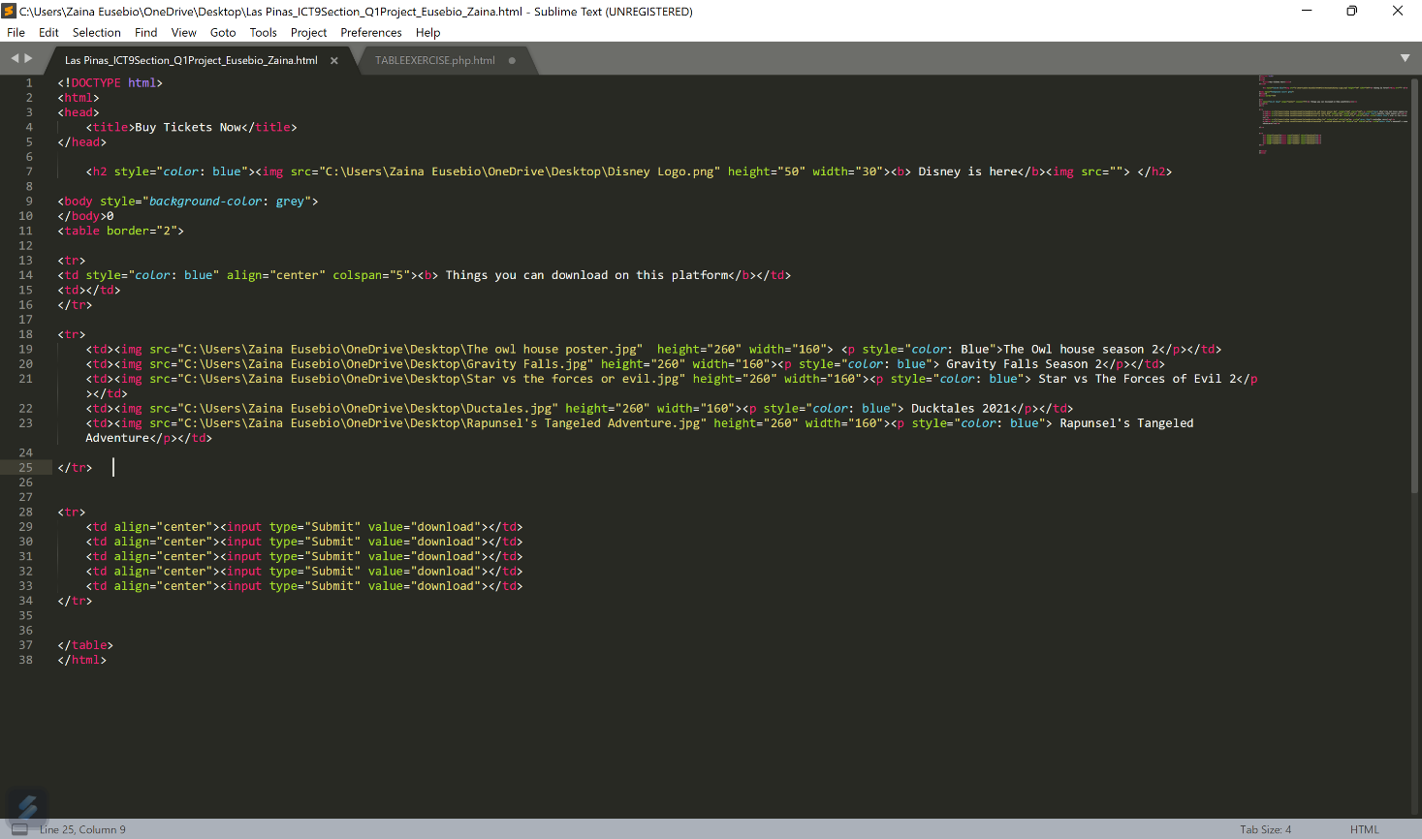

**OUTPUT (insert screen captures of your output from the browser)**

